

**Polling District and Polling Place Review 2025**

**Newbiggin Hall and Callerton Ward**

**Parliamentary Constituency:** Hexham | Central and West

**(Proposed) Polling Districts:** S01, S02, S03, S04

The Local Government Boundary Commission for England are an independent body accountable to Parliament. They are responsible for reviewing councils to make sure their patterns of internal wards are fair and sensible. Their reviews include at least two rounds of public consultation before they make recommendations for change.

The final recommendations were published on 7 January 2025, and the new arrangements apply to local elections from 2026.

As a result of changes to ward boundaries the Acting Returning Officer (ARO) is conducting a review of polling districts and polling places to ensure that they are suitable for the new ward boundaries.

For more information on the local government boundary review visit: <https://www.lgbce.org.uk/all-reviews/newcastle-upon-tyne>

This document provides details of the review, along with the initial recommendations and comments of the Acting Returning Officer (ARO). Also, the election rules require the ARO to decide how many polling stations are required for each polling station and the ARO must allocate electors to the polling stations in such manner as they think most convenient.

These recommendations will be open to all residents, stakeholders, and any interested parties. We shall be seeking representations from local disability groups on the accessibility and suitability of polling places. Any comments should be addressed in the first instance to pollingplaces@newcastle.gov.uk where they will be collated on behalf of the (Acting) Returning Officer.

We considered the following factors:

* **Identifying new polling places:** We will look for new polling places in areas where the existing provision is unsuitable or unavailable.
* **Feedback:** We will consider feedback received following recent elections, consultation from members of the public, elected members, and other stakeholders.
* **Accessibility:** We will try to ensure that every polling place is accessible to electors with disabilities.
* **Facilities**: We will make sure that all electors have such reasonable facilities for voting as are practicable in the circumstances.
* **Elector numbers:** We will try to comply with the Electoral Commission guidance on the maximum number of electors that should be allocated to a polling station which should not exceed 2,250.
* **Future housing developments**: We will consider the impact of proposed housing developments on polling station electorates.

**(Current) Kingston Park South & Newbiggin Hall**

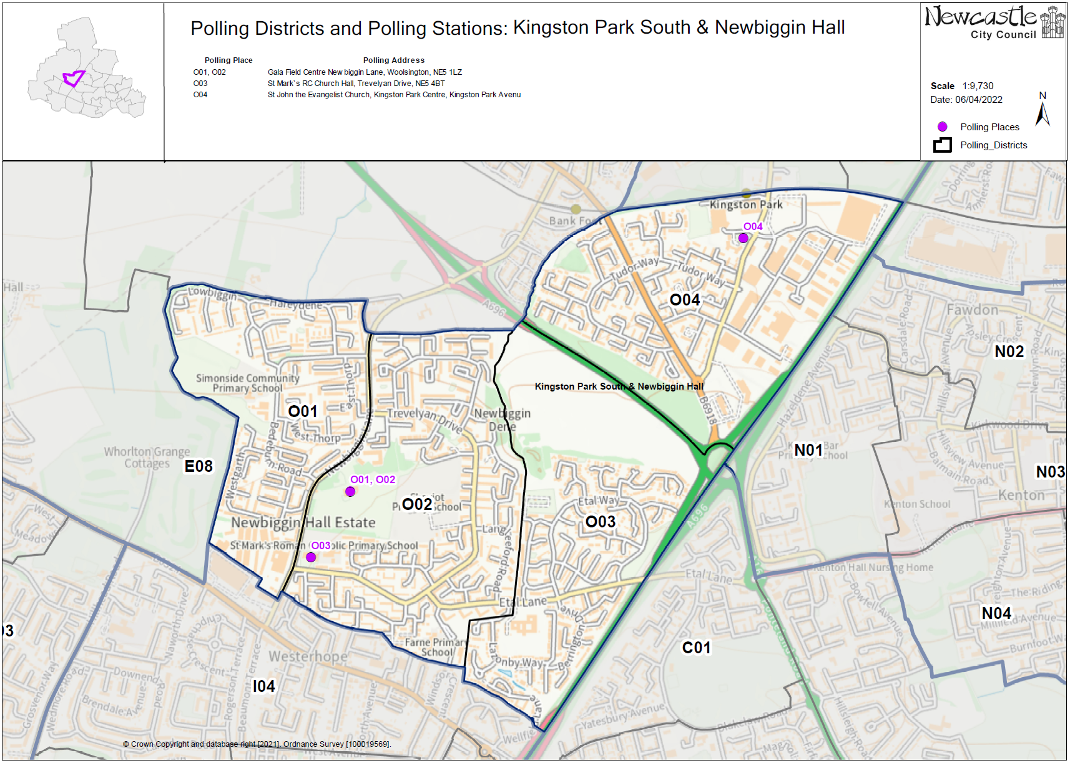These maps show the current wards and polling district boundaries and the polling places

**(Current) Callerton & Throckley**

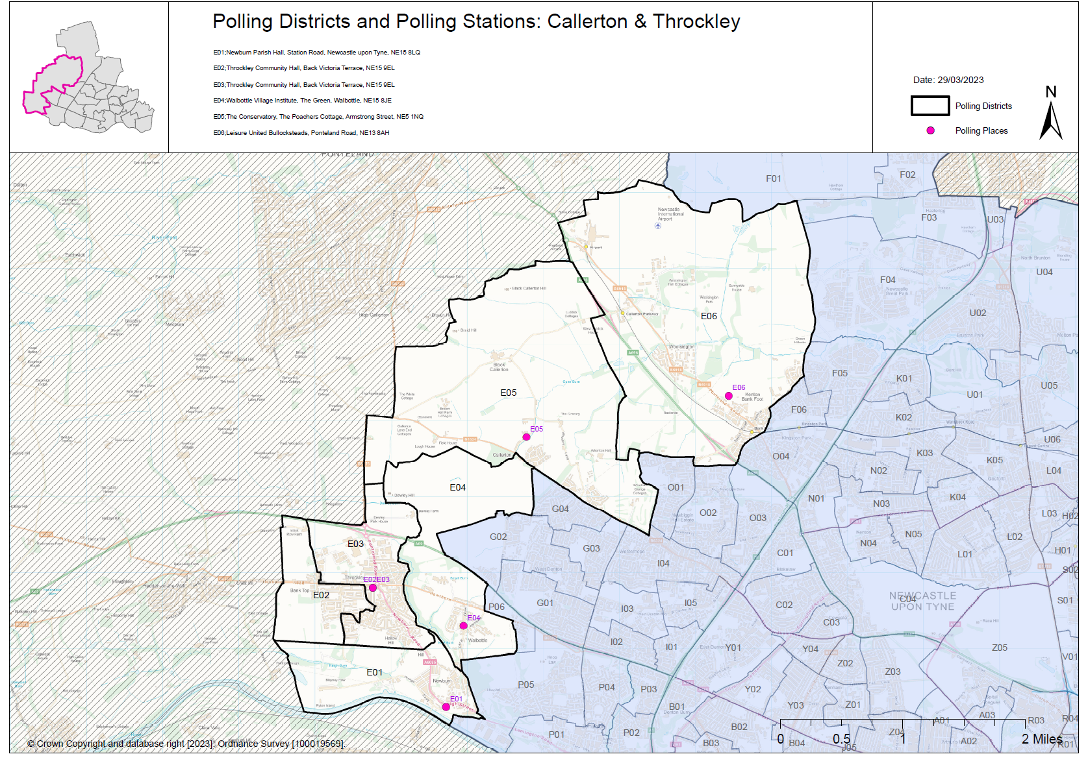

**(New)**

**Newbiggin Hall and Callerton Ward**

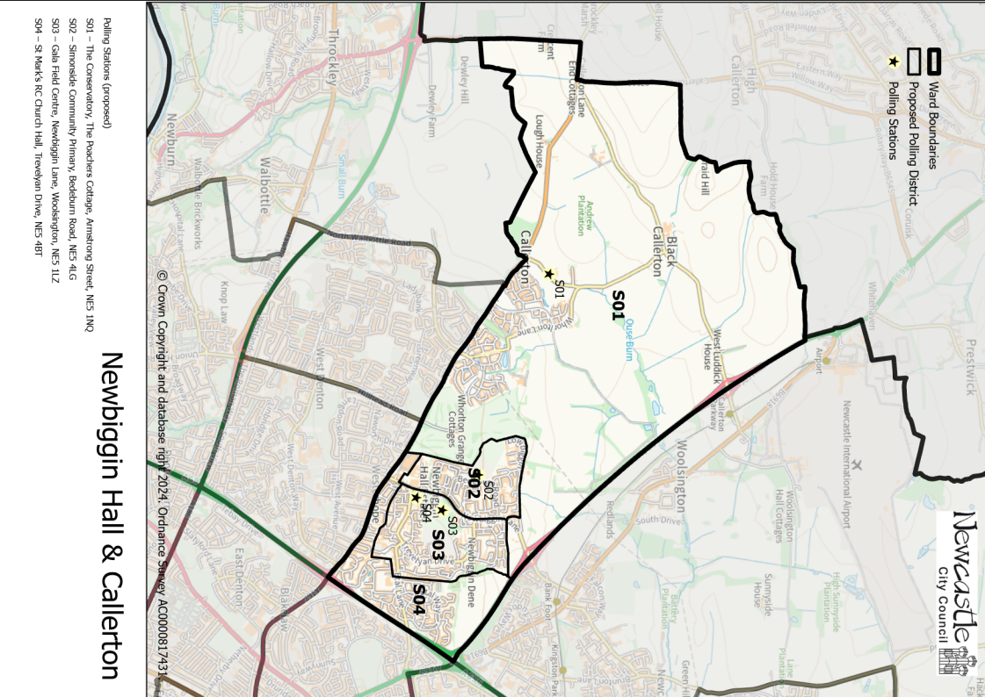

This map shows the new ward and the proposed polling districts and the proposed polling places.

* **S01**

The Conservatory, The Poachers Cottage, Armstrong Street, NE5 1NQ

* **S02**

Simonside Community Primary, Bedeburn Road, NE5 4LG

* **S03**

Gala Field Centre, Newbiggin Lane, Woolsington, NE5 1LZ

* **S04**

St Mark’s RC Church Hall, Trevelyan Drive, NE5 4BT

**Newbiggin Hall and Callerton Ward**

**Polling District S01**

|  |  |  |
| --- | --- | --- |
| **Current Polling District** | | **Current Polling Place** |
| E05 (full)  E06 (part of) | | The Conservatory, The Poachers Cottage, Armstrong Street, NE5 1NQ  Leisure United Bullocksteads, Ponteland Road, NE13 8AH |
|  | | |
| **Proposed Polling District** | **Predicted Polling Station Electorate** | **Proposed Polling Place** |
| S01 | 1384 | The Conservatory, The Poachers Cottage, Armstrong Street, NE5 1NQ |
|  | | |
| **Considerations and Proposals** | | |
| Current E05 district and part of current E06 would merge to form the proposed S01 district.  The Conservatory is centrally located within the proposed district. | | |
|  | | |
| **Preliminary Consultation – Elected Members comments and feedback** | | |
| No comments received. | | |

|  |  |  |
| --- | --- | --- |
| **Current Polling District** | | **Current Polling Place** |
| O01 (full) | | Gala Field Centre, Newbiggin Lane, Woolsington, NE5 1LZ |
|  | | |
| **Proposed Polling District** | **Predicted Polling Station Electorate** | **Proposed Polling Place** |
| S02 | 1024 | Simonside Community Primary School, Bedeburn Road, NE5 4LG |
|  | | |
| **Considerations and Proposals** | | |
| Current O01 is now the proposed S02. No change to the polling district boundary.  Simonside Primary is centrally located within the proposed S02 district so is the suggestion for this area. | | |
|  | | |
| **Preliminary Consultation – Elected Members comments and feedback** | | |
| No comments received. | | |

**Newbiggin Hall and Callerton Ward**

**Polling District S02**

|  |  |  |
| --- | --- | --- |
| **Current Polling District** | | **Current Polling Place** |
| O02 (full) | | Gala Field Centre, Newbiggin Lane, Woolsington, NE5 1LZ |
|  | | |
| **Proposed Polling District** | **Predicted Polling Station Electorate** | **Proposed Polling Place** |
| S03 | 1672 | Gala Field Centre, Newbiggin Lane, Woolsington, NE5 1LZ |
|  | | |
| **Considerations and Proposals** | | |
| Current O02 would become the proposed S03. No change to the polling district boundary.  No change to the polling place. | | |
|  | | |
| **Preliminary Consultation – Elected Members comments and feedback** | | |
| No comments received. | | |

**Newbiggin Hall and Callerton Ward**

**Polling District S03**

|  |  |  |
| --- | --- | --- |
| **Current Polling District** | | **Current Polling Place** |
| O03 (full)  I04 (part of) | | St Mark’s RC Church Hall, Trevelyan Drive, NE5 4BT  Westerhope Methodist Church, Stamfordham Road, NE5 5HA |
|  | | |
| **Proposed Polling District** | **Predicted Polling Station Electorate** | **Proposed Polling Place** |
| S04 | 1013 | St Mark’s RC Church Hall, Trevelyan Drive, NE5 4BT |
|  | | |
| **Considerations and Proposals** | | |
| Current O03 and part of the current I04, would merge to create the proposed S04 district.  Farne Primary School was considered but not deemed suitable as a polling station.  St Mark’s RC Church Hall is in the newly proposed S03 district, however there are no suitable alternatives within the proposed S04. | | |
|  | | |
| **Preliminary Consultation – Elected Members comments and feedback** | | |
| No comments received. | | |

**Newbiggin Hall and Callerton Ward**

**Polling District S04**

THIS PAGE IS INTENTIONALLY BLANK